1.) double linked list (using structure in class).cpp (output)

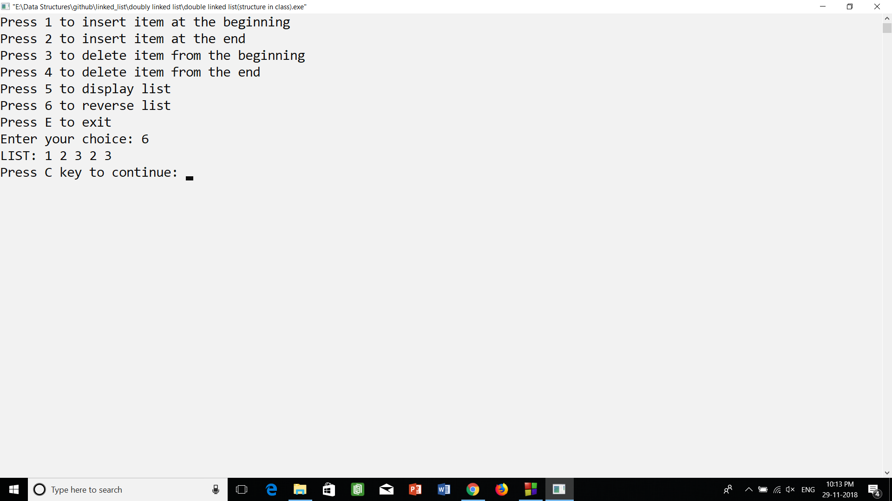

2.) double linked list (using struct and class).cpp (output)

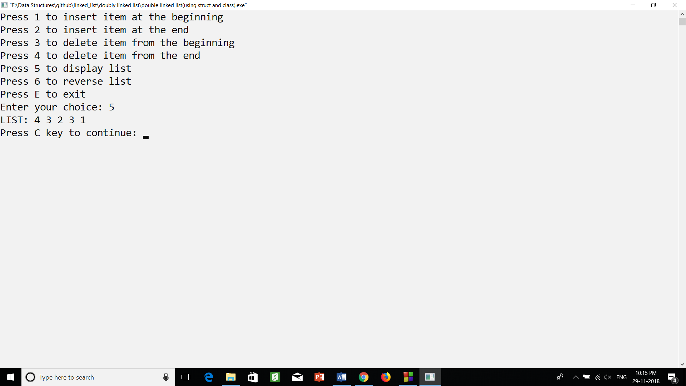

3.) double linked list.cpp (output)

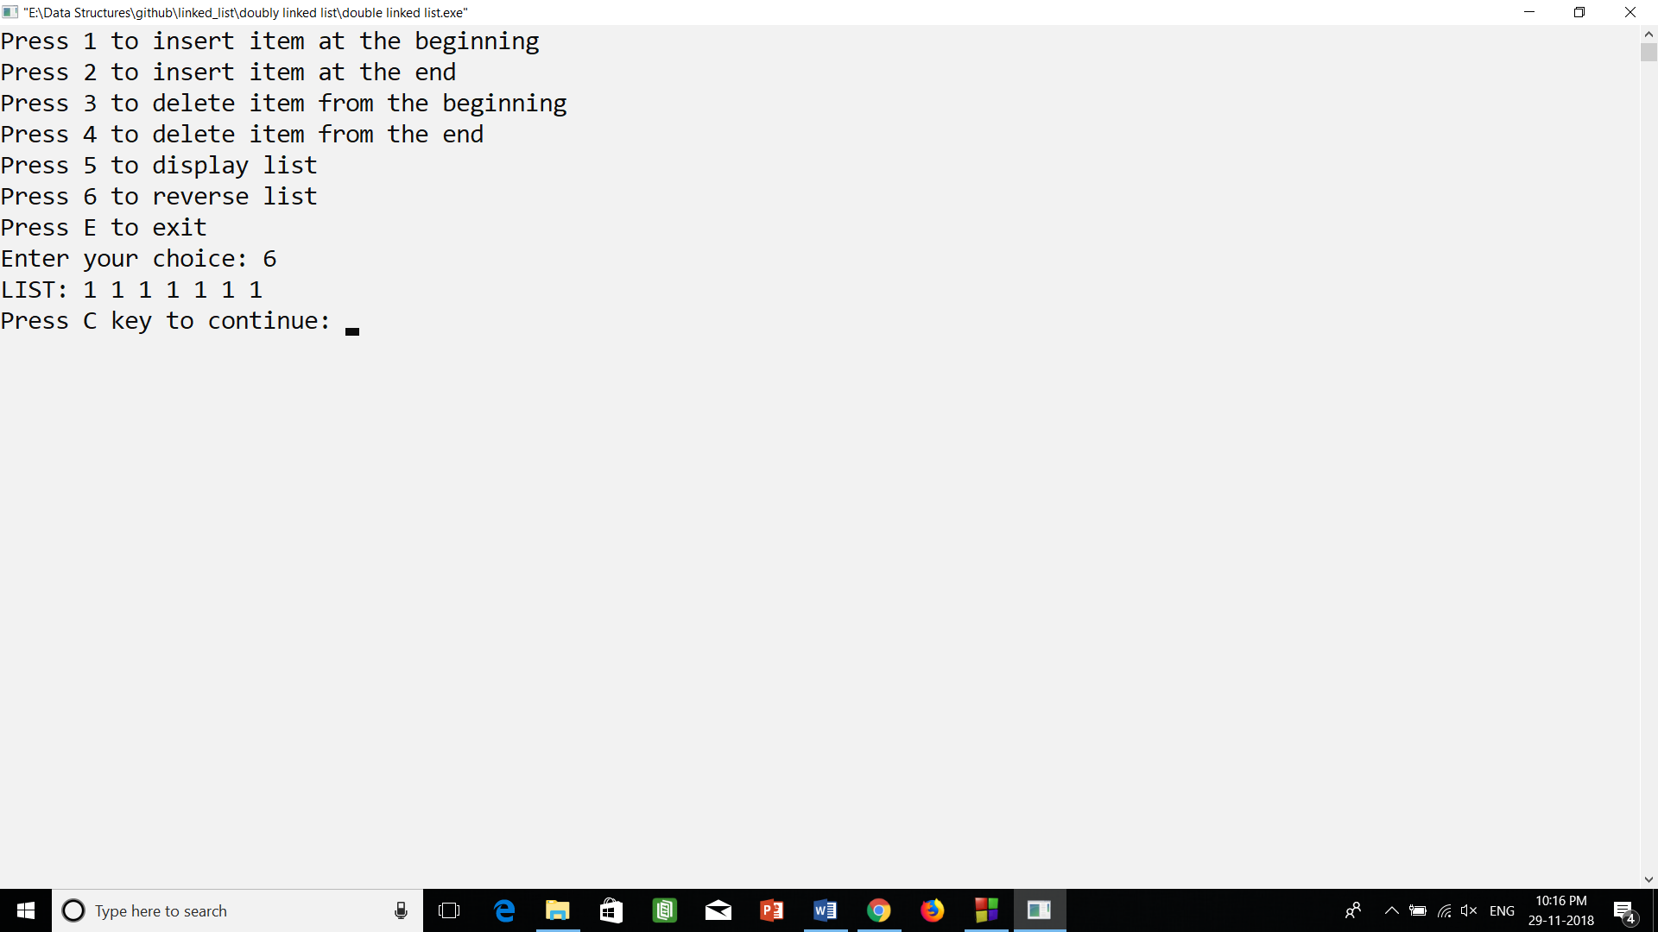

4.) doubly linked list (using class).cpp (output)

